Introduction to Deep Learning: assignment 2

In this assignment, you have to train UNet model for this competition ([link](https://www.kaggle.com/competitions/bkai-igh-neopolyp)) and get result over 0.7 on the test set. You can check your score on Leaderboard. I also provide you with a link to submit your score after.

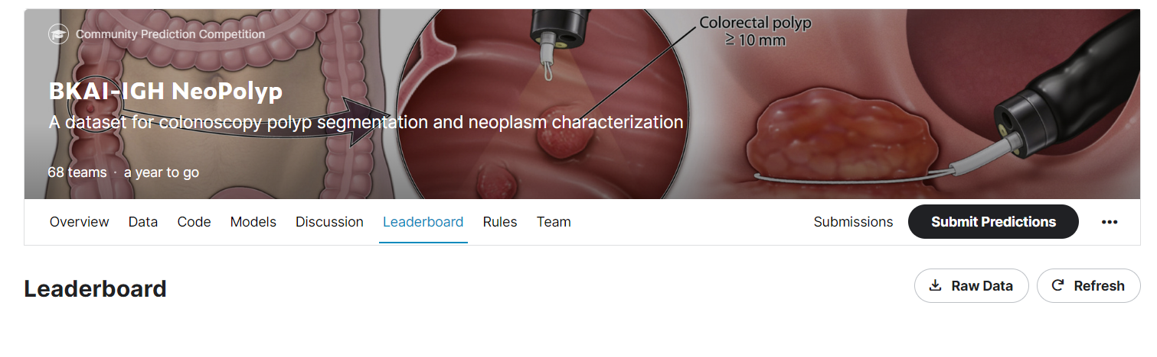

For the assignment submission:

* Small report:
  + What are the transformation techniques you used?
  + What you have changed in the model architecture?
  + Plots of your loss during training (using wandb)
  + Link to your github repository

Note that I’ll check your result using Kaggle so I prefer you to push your code to github repository and have 1 python file name **infer.py.** I will run your code as below.

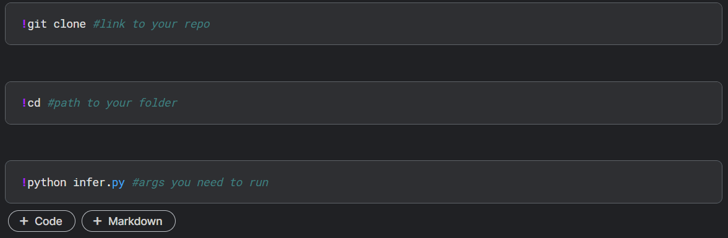

Please have instructions for me to run your infer file. For instruction, **all scripts have to be able to ctrl+C and ctrl+V** (don’t capture your screen because it takes me lots of time to type your script again).